CS 4820 Preliminary 2 Review

1. Short answer
   1. False.

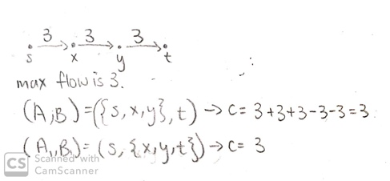

* 1. No; flow through of value .



* 1. ;
  2. P vs. NP
     1. P; run BFS or DFS to find all paths from $s$ to $t$ and see if any of them use less than or equal to $k$ edges.
     2. P; same answer as above but check if any use more than or equal to $k$ edges

1. Run FF on this. If the max flow $v<km$, then there’s no valid arrangement. There are $n+\sum_{i∈X}{|C_{i}|}+m$ edges. $C$ is $2n$. Runtime on this would be $O(2n^{2}+2n^{2}m+2nm)$.
2. Given an answer of $m≤k$ students, it is easy to verify in polynomial time whether this results in each class having at least $p$ trained students.

We will convert the decision version of vertex cover into ProjecterHelper. Given a graph $G(V,E)$ and integer $k$, we want to know where there exists $I⊂V$ such that $\left|I\right|≤k$ and that $I$ coverts $E$. We will reduce this to ProjecterHelper by making all the nodes a student and all the incident edges of a node the student’s classes. $k$ of this project is $k$ from vertex cover and $p=1$. This is obviously a polynomial time reduction.

The answer from ProjectorHelper is the answer to vertex cover. This is also obviously a polynomial time reduction.

Vertex cover is NP-complete. This reduction is correct because if and only if the $m<k$ students returned by ProjecterHelper ensures all classes have at least $1$ helper does there exist an $I⊂V$ such that $\left|I\right|≤k$ and that $I$ coverts $E$.